**EMERGENCY PROCEDURES**

*Folke Bernadotte Memorial Library*

*Gustavus Adolphus College*

*St. Peter, Minnesota*

## EMERGENCY CALL:

**9-911**

Secondary Emergency:

(not life threatening)

x8888

**Revised Spring 2013Table of Contents**

***Introduction***…………………………………………………………………3

***Emergency Telephone Numbers***

On-campus contacts………………………………………………………….4

Off-campus contacts ……………………………………………...................4

*City of St. Peter*…… ………………………………………………….4

***Procedures***

Computer System Back-Up……………………………………….................5

Elevator Failure……………………………………………………………...5

Evacuation Procedures……………………………………………................5

Evening and Weekend Hours………………………………………………..5

Fire or Smoke ……………………………………………….........................6

Fumes/Gas/Stench…………………………………………………………...6

Medical Emergency………………………………………………………….7

Mold………………………………………………………………………....7

Power Outage………………………………………………..........................7

Problem Patron……………………………………………………................7

Severe Weather………………………………………………………………8

Terrorist Threat ……………………………………………………………...8

Water (Leak, Flood, Plumbing)……………………………...........................8

Buddy System Chart……………………………………………....................8

Emergency Roster……………………………………………………………8

Emergency Exits (and map)……………………………………….................9

***Emergency Equipment***

Location of emergency equipment……………………………………....10-11

Location of fire extinguishers, alarms, and sensors…………………….12-14

***Introduction***

These procedures are intended to detail immediate responses to emergency situations. Members of the library staff should become familiar with these procedures and the locations of supplies such as fire extinguishers, flashlights, etc. During any emergency the first rule is to use common sense; appropriate responses will vary with the situation**. Personal safety and that of our patrons should always be our primary concern.**

Another component of emergency preparedness is to insure that each member of the staff has the knowledge necessary to follow the written procedures effectively and confidently. For that reason, training sessions and drills, as well as revision of the written procedures and inventory of supplies, should be an on-going process. This plan should be reviewed annually for any changes.

Please consult the Emergency Plan for Gustavus Adolphus College (<https://gustavus.edu/smc/>) for further information on campus-wide emergencies or situations that would involve personnel outside the library.

***Emergency Telephone Numbers***

***On-campus contacts:***

Health Service

Monday to Friday, 8:00 am - 4:30 pm………………………………….......7630

Physical Plant

Monday to Friday, 7:00 am-noon; 1:00-4:00 pm…………………………..7504

Campus Safety (anytime)………………………………………………............8888

Computer Center Helpline (regular semester hours)…………………………..6111

Monday to Thursday, 8:00 am – 11 pm

Friday, 8:00 am – 4:45 pm

Saturday, 12:00 pm – 5:00 pm

Sunday, 3:00 pm – 11 pm

Fire and Water Damage Recovery:

Warren Wunderlich (primary contact)…………………………………………7504

***Off-campus contacts:***

**City of St. Peter:**

Emergency…………………………………………………….9-911 or 9-931-1550

Fire Department……………………………………………….9-911 or 9-931-1550

Ambulance…………………………………………………….9-911 or 9-931-1550

Police Dispatch………………………………………………..9-911 or 9-931-1550

# **General Information and Referral:**

Minnesota Historical Society………………………………………...651-296-6126

Poison Control Center ……………………………………………….800-222-1222

***PROCEDURES***

**COMPUTER SYSTEM BACK-UP:**

Each workstation in the building should have a rotation of regularly scheduled back-ups. These back-ups should be the irreplaceable files from each station’s hard drive and not the commercial software that can be replaced in the event of a disaster. (Examples would be database files that cannot be easily constructed, finding aids for collection items, correspondence filed electronically, etc.) Contact Jessie Twaddle (7443) with any questions.

**ELEVATOR FAILURE:**

* Check to see if anyone is trapped in the elevator.
* If you are trapped in the elevator, use emergency phone and push red button for help.
* Do not force the elevator doors open.
* During business hours, contact Physical Plant (x7504). During evenings and weekends, contact Campus Safety (x8888).

**EVACUATION PROCEDURES:**

* Leave the building without delay. Ignore any door alarm and proceed outside through the nearest exit.
* Use stairs. Do not use elevators unless so authorized by safety officers.
* In the case of a bomb threat, stand at least 300 feet away from the building.
* Take personal items with you only if that can be done quickly.
* Secure your office or area as time permits.
* As staff leave the building, they should instruct anyone they see along their escape route to leave as well.
* Once patrons are informed of an evacuation, staff should leave without regard for persons who refuse to leave.
* Staff (as well as patrons) should congregate on the sidewalk/stairs on the east side of the building to account for all staff and student help known to be working at the time. Utilize the ‘Buddy System’ to ensure that all staff are present *(see list on page 8). The alternate location is the north side of the building.*
* Staff should notify police or fire personnel of the location of persons remaining in the building, such as disabled persons.
* Circulation posts staff at all entrances *(including the far side of the Student Union Breezeway),* voluntarily and only if it appears safe to do so a reasonable distance from building, to keep people from entering or re-entering the building. These posts should be a reasonable safe distance from the building again always using common sense with each evacuation scenario.

**EVENING AND WEEKEND HOURS**

During the evening and weekend hours when a librarian is not on duty, Peer Supervisors are in charge of the library. The Circulation Manager is responsible for the training of all Peer Supervisors to carry out all emergency procedures for the library. The Peer Supervisors have the authority to react and respond to any emergency situation and also the responsibility to notify the proper college officials.

**FIRE OR SMOKE:**

In the event of a fire, before following through with any evacuation plan, always use COMMON SENSE first, as the real thing may be different than any scenario practiced via drills.

Staff should familiarize themselves with the locations of all fire exits, fire pull stations and fire extinguishers.

* Persons discovering fire or smoke in any part of the library will:
* Activate a fire alarm from the nearest pull station
* Call Campus Safety at Extension 8888
* Call 9-911
* The caller will provide information including: building, location, floor level, type of fire (flame or smoke) and name of caller.
* After the alarm is activated:
* Do not fight the fire unless specifically trained to do so.
* All staff should meet near librarians’ reference desk to determine whom shall make sweep of each floor to ascertain all patrons are aware of fire alarm, particularly patrons in study rooms.
* Staff are to alert those on each floor of necessity to leave, but do **not** have to escort them out.
* All student employees will be trained to become the “sweepers” in case of fire after business hours.
* Use stairs only. Do not use elevators.
* Close doors, if time permits.
* Crawl low in smoke. Cover your nose and mouth with a wet cloth, if possible.
* Touch closed doors. Do not open them if they feel hot.
* If escape routes are blocked by heat or heavy smoke, seek an area of refuge or stay in a room with the door closed and opening sealed until help arrives.
* Evacuate the building, using the closest emergency exit near you.
* Staff should notify police or fire personnel of the location of persons remaining in the building, such as disabled persons.

All staff (as well as patrons) meet at designated rendezvous location - the sidewalk/stairs on the east side of the building. The alternate location is the north side of the building.

**FUMES/GAS/STENCH:**

* During business hours, contact Physical Plant (x7504). During evenings and weekends, contact Campus Safety (x8888).
* When reporting the details:
  + Describe the nature of the fumes
  + Give location: building, floor, room
  + Give your name and phone number
* If a person shows symptoms of having breathed toxic fumes, follow the procedures under Medical Emergency.

**MEDICAL EMERGENCY:**

* Unconscious person
  + Call 9-911 immediately.
  + Look for a Medic Alert bracelet on the person's arm. Check the underside of the bracelet for additional information.
  + Ask if anyone in the area saw what happened.
  + Call Campus Safety (x8888)
* Conscious person
  + Ask the person to describe the problem and any related health conditions.
  + Try to make the person as comfortable as possible.
  + Ask if anyone in the area saw what happened.
  + Call Campus Safety (x8888)

**MOLD:**

* During business hours, contact Campus Safety (x7494). If mold is discovered during the evening or weekend, wait until the next business day to contact Campus Safety.
* Don’t disturb the area until the mold has been looked at.

**POWER OUTAGE:**

* In the event of a power failure, emergency lights will turn on in the stairwells.
* Escort patrons from the building, if necessary. Locations of flashlights are noted on the attached “Emergency Equipment” list*. [If a patron refuses to leave or move, inform the patron that you will be calling Campus Safety*.]
* During business hours, contact Physical Plant (x7504). During evenings and weekends, contact Campus Safety (x8888).
* If the power fails in the evening or on the weekend, students working at the Circulation Desk should lock the front doors. One student should call Campus Safety (8888) and then wait for an officer. The other student should assist patrons in leaving the building.
* Closure of the library will be determined by the Library Chair. If the Chair is not available, contact Campus Safety to determine source and length of outage. If outage is anticipated beyond one hour, close the building.

**PROBLEM PATRON:**

* Speak calmly and firmly; do not allow yourself to be manipulated.
* Do not argue with the person or take his or her anger personally.
* Never touch or try to restrain a person.
* Listen supportively, with empathy and understanding.
* Acknowledge that you hear what the person is telling you.
* Explain the policies and procedures that pertain to the situation.
* Describe steps that can be taken to solve the problem.
* If you cannot resolve a complaint, refer it to the Library Chair.
* Try to move person to a non-public area to minimize disturbance to others.
* Obtain a written statement from others involved, as appropriate.
* Call Campus Safety (x8888) if you are concerned about your safety, the safety of others or possible damage to the library.

**SEVERE WEATHER (Tornado Warning):**

* Escort patrons to basement level by walking through center of each floor alerting all to seek lower level staying away from windows at all times. *[If a patron refuses to leave or move, inform the patron that you will be calling Campus Safety.]*
* Leave front doors unlocked.
* Patrons are to gather in AV 1/AV 2 with staff to gather in staff lounge where battery-operated radio is available.

**TERRORIST THREAT:**

While receiving a bomb threat by phone:

* Keep the caller on the phone as long as possible.
* Try to have someone call Campus Safety (x8888)
* Evacuate building.

**WATER (Leak, Flood, Plumbing):**

* Cover affected area(s) with plastic sheeting.
* Put buckets under leaks.
* During business hours, contact Physical Plant (x7504). During evenings and weekends, contact Campus Safety (x8888).
* Explain the situation. *(They would like to get to the source of the problem and analyze the potential for mold or other airborne problems.)*

**THE BUDDY SYSTEM CHART:**

***(This chart is for permanent library personnel. It is to be used to ascertain the safety and whereabouts of those listed in the event of an emergency.)***

#### Amanda, Anna, Diane

Ginny, Barbara, Michelle, Jessie/Paul

Dan, Jeannie, Julie

Jay, Sonja, Jeff

Lynn, Adrianna, Melissa

**EMERGENCY ROSTER**

An emergency roster is located at the back door of the receiving room as well as near the front doors near the master keys in the administrative office (Jeannie’s area). This roster includes contact information for library and non-library personnel with offices in library. This roster should be seized during evacuation to be used for accountability once outside library.

**EMERGENCY EXIT DOORS:**

* Located in the east and south stairwells, between the first and second floors
* If the glass on the emergency exit doors is broken, the alarm will sound on the doors and at the Circulation Desk.
* To deactivate alarm:
  + Go to first floor and pull door shut. A timer will automatically shut off the door alarm.
  + Go to the alarm at the Circulation Desk and push the reset button.

**LOCATION OF EMERGENCY EXITS:**



***EMERGENCY EQUIPMENT***

**LOCATION OF EMERGENCY EQUIPMENT**

**Buckets:**

Custodial Supply Room

Loading Dock-Second Floor

**Cut-off switches and valves**:

*Electric* Mechanical Room

*Water* Mechanical Room

**Dehumidifier:**

Mechanical Room

**Extension cords:**

Custodial Supply Room

2nd floor Custodians’ Closet

Technical Services Supply Closet

**Fire alarms**:

Each floor (map attached); Alarm system in Mechanical Room

**Fire extinguishers:**

Perimeter of every floor (map attached)

**First aid supplies:**

# Circulation

# Custodial Supply Room

Mail Station

**Flashlights:**

One for each staff member, and/or the following offices:

Administration ILL

Archives Periodicals

Audio-Visual Reference Desk

Circulation (3) Staff Room

Government Documents Technical Services

**Ladders:**

First Floor—Assorted sizes in Mechanical Room and Custodial Supply Room

Second Floor—Tall ladder in Custodians’ Closet

### Mops:

Custodians’ Closet, First and Second Floor

### Plastic Sheeting:

Custodians’ Closet—Third Floor

Archives

Administrative Office Closet

**Plastic trash bags:**

Custodial Supply Room

**Radios:**

Circulation has a campus-issued weather alert radio

Staff Lounge

Technical Services

Custodians’ Closet—Third Floor

Archives Office

**Vacuum:**

Custodians’ Closet, First and Second Floor

Custodial Supply Room

**Wet-dry vacuum:**

Mechanical Room

**LOCATION OF FIRE EXTINGUISHERS, ALARMS, AND SENSORS:**

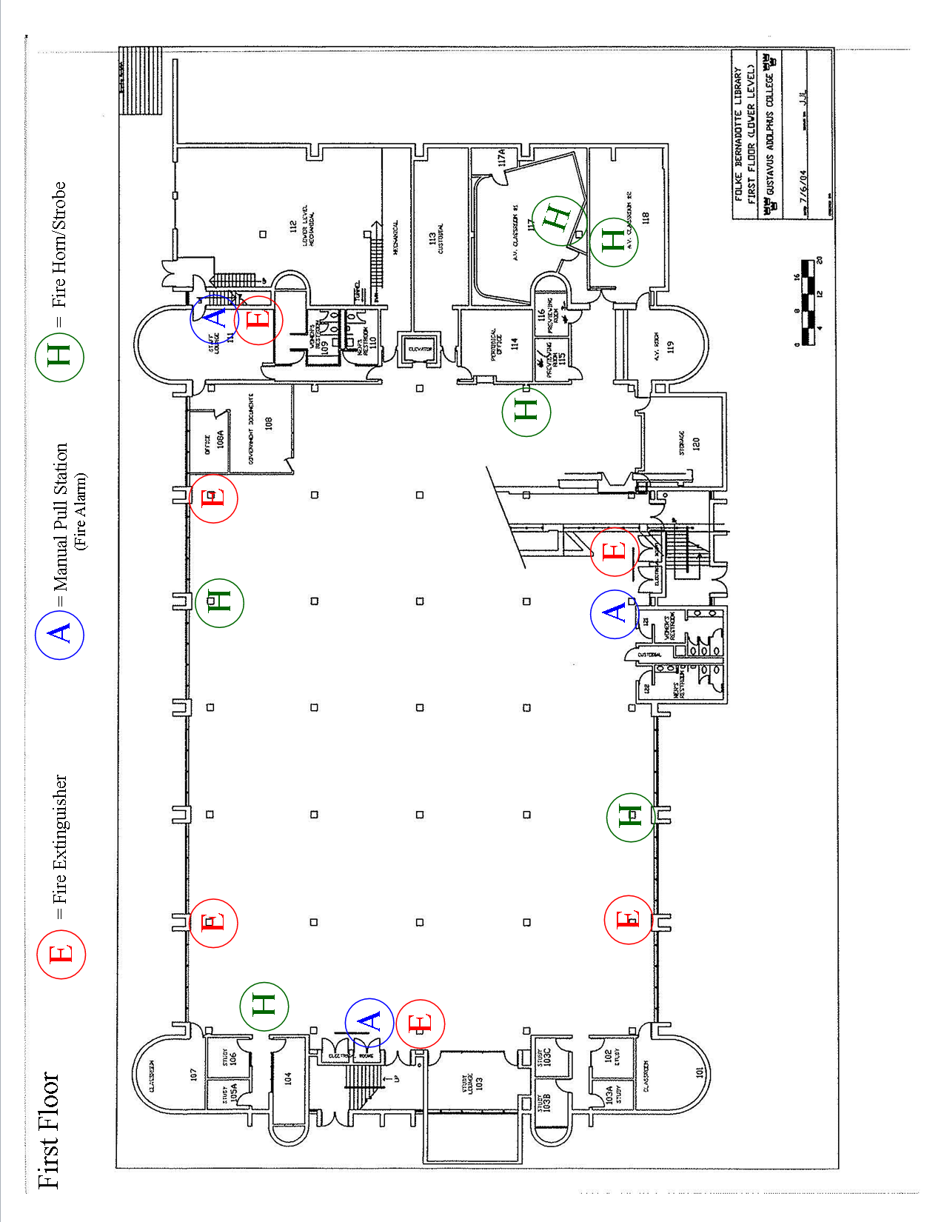

**LOCATION OF FIRE EXTINGUISHERS, ALARMS, AND SENSORS:**

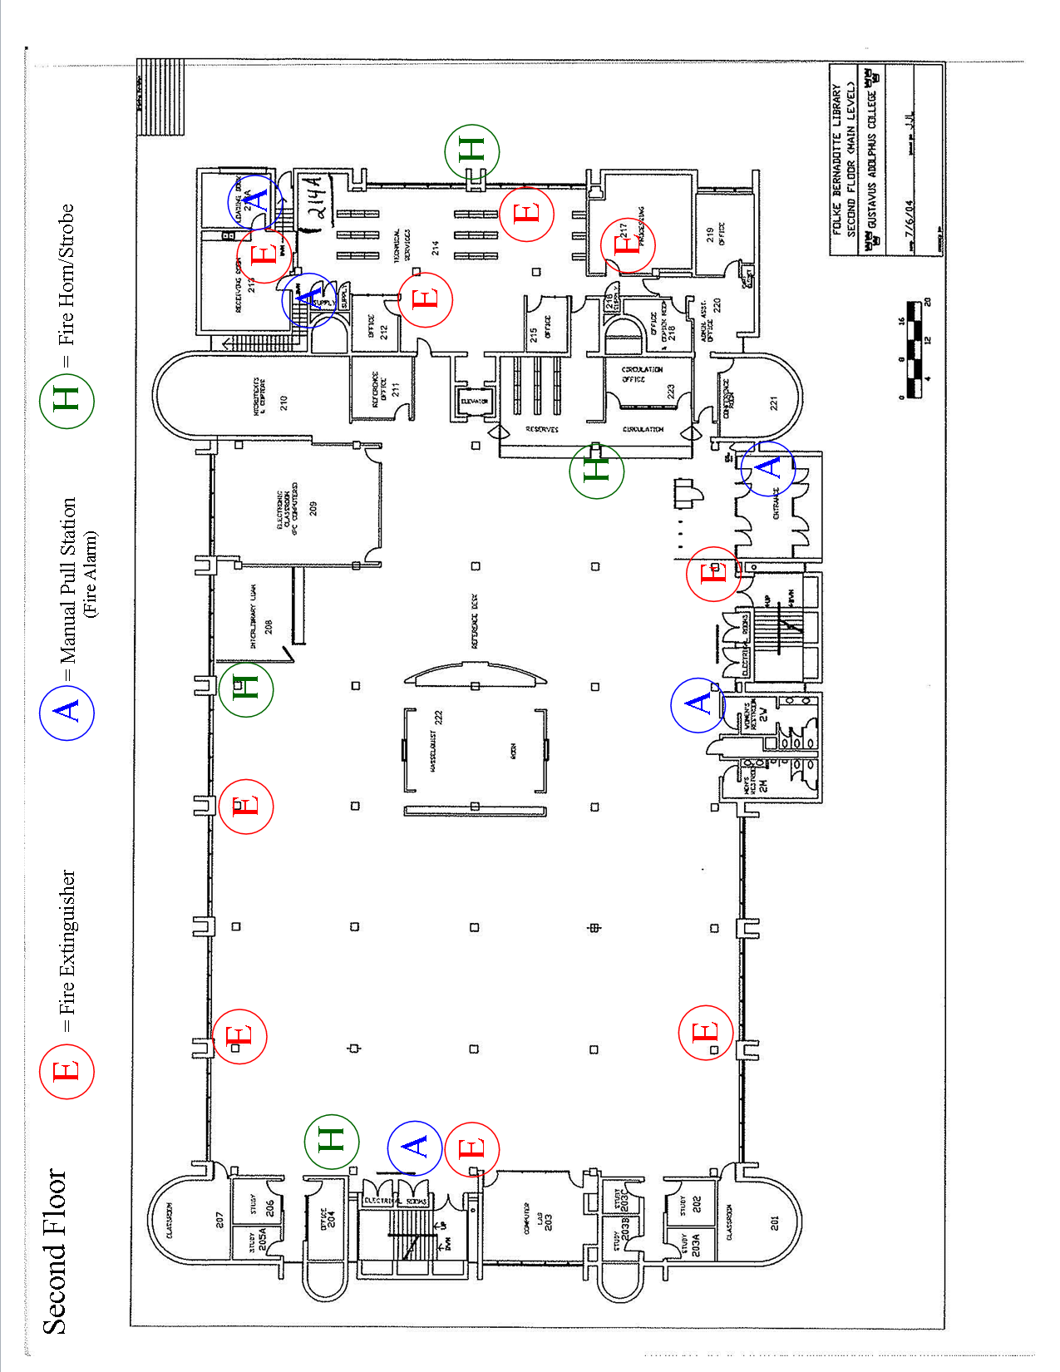

**LOCATION OF FIRE EXTINGUISHERS, ALARMS, AND SENSORS:**

